Experiment No. 5
Student Name: Ojaswini Thote
PRN: 24070521048
File Path: file:///Users/ojaswinithote/Desktop/Javascript/EXP%205/Practical/index.html file:///Users/ojaswinithote/Desktop/Javascript/EXP%205/Case%20Study/index1.html

Experiment Title
Apply array methods and object handling; create a cart total calculator with discount logic.

Software / Tools Required
- Visual Studio Code
- Google Chrome
- HTML5
- JavaScript (ES6)

Task 5.1 — Shopping Cart Calculator

Aim
Demonstrate JavaScript array methods — forEach, map, filter, and reduce — using a Shopping Cart Calculator with product objects.

File Path
file:///Users/ojaswinithote/Desktop/Javascript/EXP%205/Practical/index.html

Program Code

Task5/5.1/index.html
<!DOCTYPE html>
<html lang="en">
<head>
<meta charset="UTF-8">
<meta name="viewport" content="width=device-width, initial-scale=1.0">
<title>Shopping Cart Total Calculator</title>

<style>

*{
margin:0;
padding:0;
box-sizing:border-box;
font-family:Arial, Helvetica, sans-serif;
}

body{
background:#ffe6f2;
padding:30px;
}

.container{
width:95%;
max-width:1400px;
margin:auto;
background:white;
border-radius:15px;
box-shadow:0 5px 15px rgba(0,0,0,0.2);
padding:30px;
}

h1{
text-align:center;
color:#d63384;
margin-bottom:30px;
}

.main{
display:flex;
gap:30px;
align-items:flex-start;
}

.left{
flex:1;
}

.right{
flex:1;
}

label{
display:block;
margin-top:15px;
margin-bottom:5px;
font-weight:bold;
}

input{
width:100%;
padding:10px;
border:1px solid #ccc;
border-radius:8px;
font-size:16px;
}

button{
width:100%;
padding:12px;
margin-top:15px;
background:#ff4d94;
color:white;
border:none;
border-radius:8px;
cursor:pointer;
font-size:16px;
}

button:hover{
background:#e60073;
}

.right h2{
color:#d63384;
margin-bottom:15px;
}

.product{
background:#fff0f6;
border-left:5px solid #ff4d94;
padding:12px;
margin-bottom:12px;
border-radius:8px;
line-height:1.7;
}

#result{
margin-top:30px;
background:#ffeaf3;
padding:20px;
border-radius:10px;
font-size:18px;
line-height:1.8;
font-weight:bold;
}

hr{
margin:12px 0;
}

@media(max-width:900px){

.main{
flex-direction:column;
}

}

</style>

</head>
<body>

<div class="container">

<h1>🛒 Shopping Cart Total Calculator</h1>

<div class="main">

<div class="left">

<label>Product Name</label>
<input type="text" id="productName" placeholder="Enter Product Name">

<label>Price (₹)</label>
<input type="number" id="price" placeholder="Enter Price">

<label>Quantity</label>
<input type="number" id="quantity" placeholder="Enter Quantity">

<button onclick="addProduct()">Add Product</button>

<button onclick="calculateBill()">Calculate Total</button>

</div>

<div class="right">

<h2>Products Added</h2>

<div id="productList">
<p>No products added.</p>
</div>

</div>

</div>

<div id="result"></div>

</div>

<script src="script.js"></script>

</body>
</html>

Task5/5.1/script.js
// Array to store product objects
const cart = [];

// Add Product
function addProduct(){

const name = document.getElementById("productName").value.trim();
const price = Number(document.getElementById("price").value);
const quantity = Number(document.getElementById("quantity").value);

if(name==="" || price<=0 || quantity<=0){
alert("Please enter valid product details.");
return;
}

// Object
const product={
name:name,
price:price,
quantity:quantity,
total:price*quantity
};

// Array Method
cart.push(product);

displayProducts();

document.getElementById("productName").value="";
document.getElementById("price").value="";
document.getElementById("quantity").value="";
}

// Display Products
function displayProducts(){

const productList=document.getElementById("productList");

productList.innerHTML="";

cart.forEach(function(item,index){

productList.innerHTML+=`
<div class="product">
<strong>${index+1}. ${item.name}</strong><br>
Price : ₹${item.price}<br>
Quantity : ${item.quantity}<br>
Total : ₹${item.total}
</div>
`;

});

}

// Calculate Bill
function calculateBill(){

if(cart.length===0){
alert("Cart is empty.");
return;
}

// Array Method - reduce()
const cartTotal=cart.reduce(function(sum,item){
return sum+item.total;
},0);

let discount=0;

if(cartTotal>=5000){
discount=cartTotal*0.20;
}
else if(cartTotal>=3000){
discount=cartTotal*0.15;
}
else if(cartTotal>=1000){
discount=cartTotal*0.10;
}

const finalAmount=cartTotal-discount;

document.getElementById("result").innerHTML=`
<h2 style="color:#d63384;">Bill Summary</h2>
Total Products : ${cart.length}<br>
Cart Total : ₹${cartTotal.toFixed(2)}<br>
Discount : ₹${discount.toFixed(2)}
<hr>
Final Amount : ₹${finalAmount.toFixed(2)}
`;

}

Array Methods Used
Method | Purpose
forEach() | Renders each cart item as a table row
map() | Builds the Item Summary list with product name and item total
filter() | Extracts products where price > 1000
reduce() | Calculates the grand total: sum + (price × quantity)

─────────────────────────────────────────────────────────────────────────────────────

Output
- User enters Product Name, Price, and Quantity and clicks Add Product.
- The table displays ID, Name, Price, Quantity, and Total for each product.
- Discount is applied automatically:
- ≥ ₹50,000 → 20% discount
- ≥ ₹20,000 → 10% discount
- ≥ ₹5,000 → 5% discount
- Final Amount = Total − Discount
- Item Summary and Expensive Products lists are updated whenever a new product is added.

Screenshot
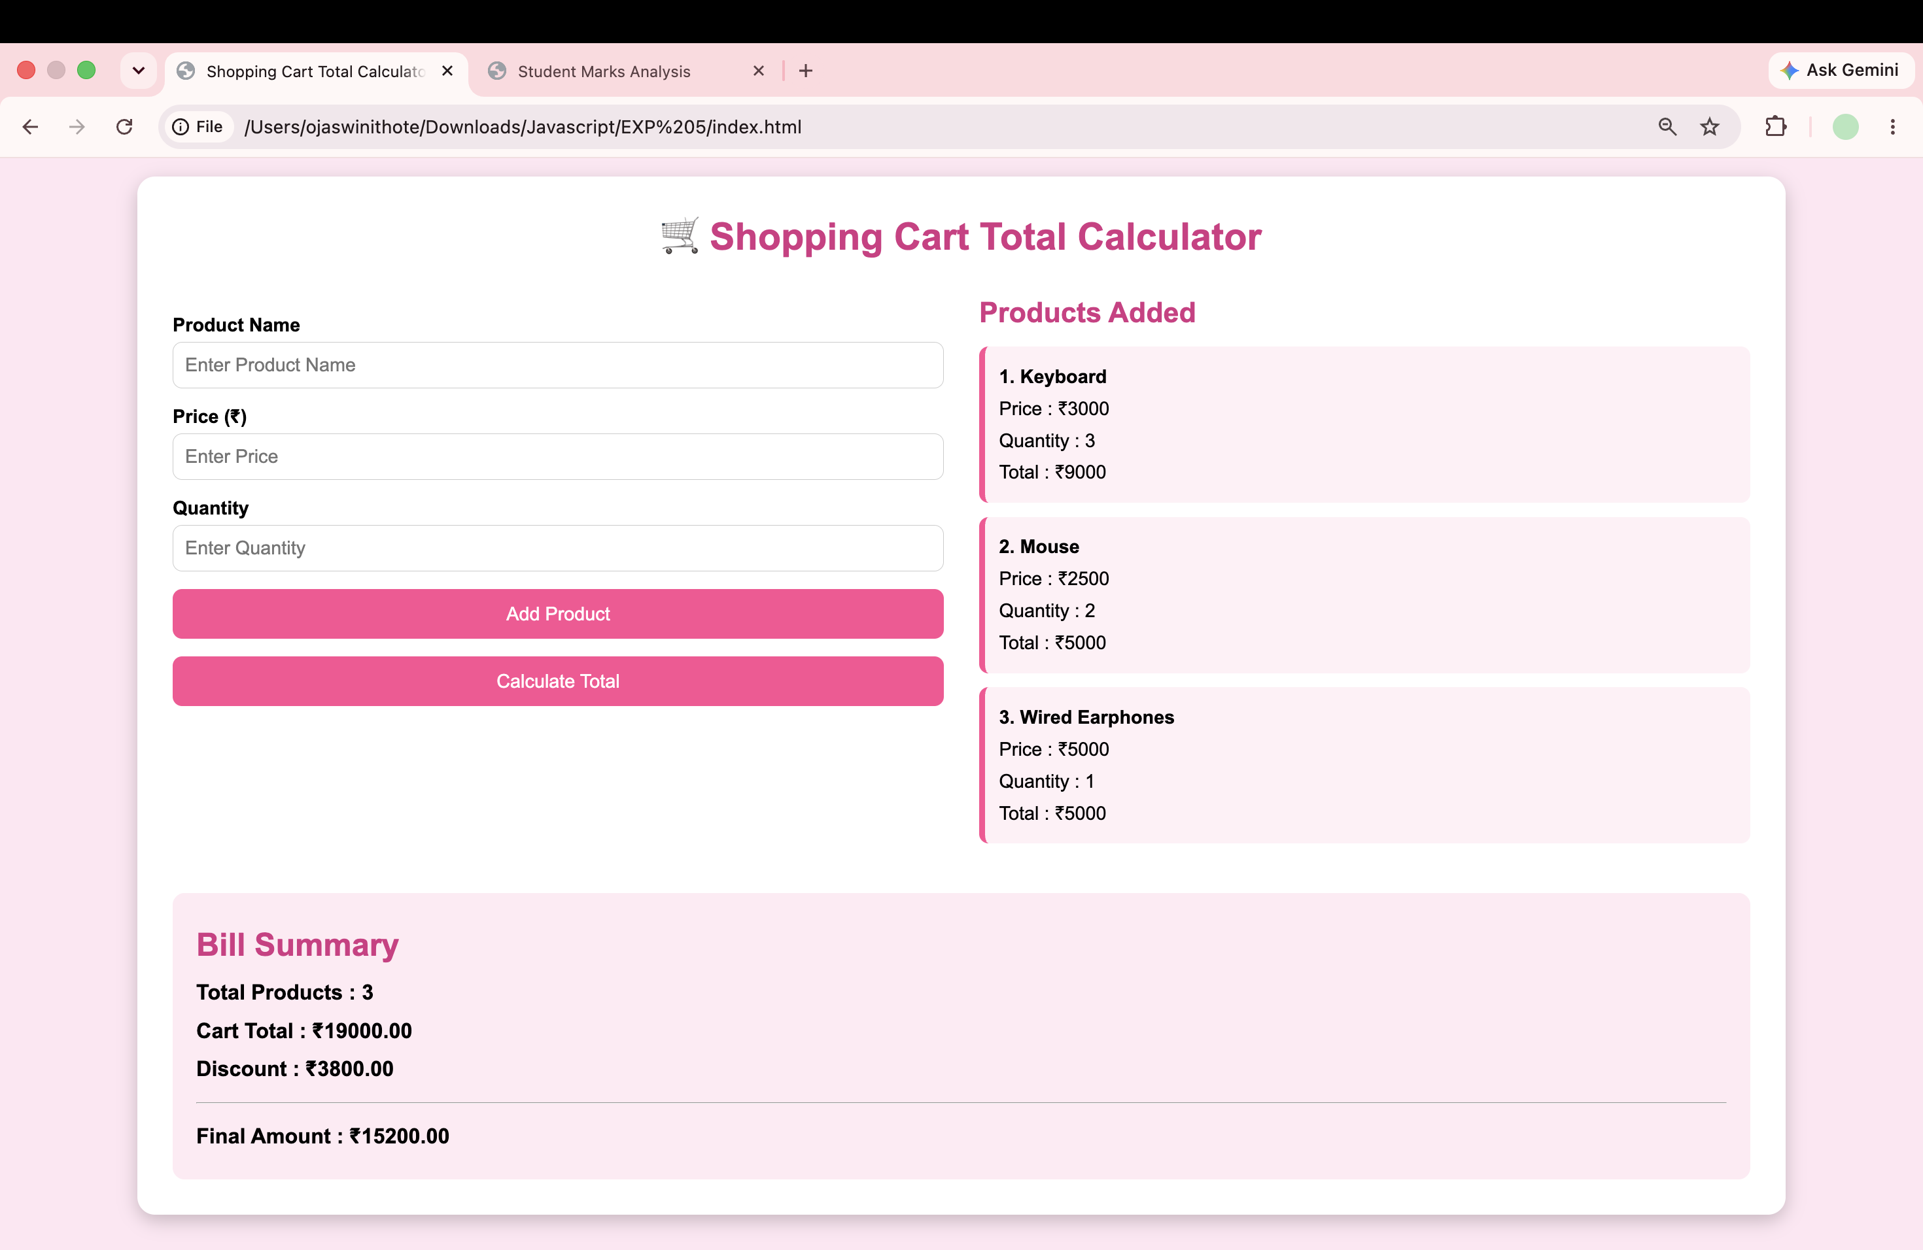

Task 5.2 — Max & Min Finder (Array of Objects)

Aim
Create an array of objects from user input and find the Maximum and Minimum values using array methods — map(), Math.max(), Math.min(), and some().

Program Code

Task5/5.2/index.html
<!DOCTYPE html>
<html lang="en">

<head>

<meta charset="UTF-8">
<meta name="viewport" content="width=device-width, initial-scale=1.0">

<title>Student Marks Analysis</title>

<style>

*{
margin:0;
padding:0;
box-sizing:border-box;
font-family:'Segoe UI',Tahoma,Geneva,Verdana,sans-serif;
}

body{
min-height:100vh;
padding:40px;
background:linear-gradient(135deg,#4facfe,#00f2fe);
}

.container{
width:95%;
max-width:1100px;
margin:auto;
background:white;
padding:40px;
border-radius:20px;
box-shadow:0 15px 40px rgba(0,0,0,.25);
}

h1{
text-align:center;
color:#0d47a1;
margin-bottom:10px;
font-size:34px;
}

.subtitle{
text-align:center;
color:#666;
margin-bottom:35px;
}

.form-section{
background:#f4f8ff;
padding:25px;
border-radius:15px;
border-left:6px solid #1565c0;
}

.form-section h2{
color:#0d47a1;
margin-bottom:20px;
}

.input-row{
display:flex;
gap:20px;
}

.input-group{
flex:1;
}

label{
display:block;
font-size:16px;
font-weight:600;
margin-bottom:8px;
color:#333;
}

input{
width:100%;
padding:13px;
border:2px solid #90caf9;
border-radius:10px;
font-size:16px;
outline:none;
}

input:focus{
border-color:#1565c0;
box-shadow:0 0 8px rgba(21,101,192,.25);
}

button{
padding:13px;
border:none;
border-radius:10px;
background:linear-gradient(135deg,#1976d2,#0d47a1);
color:white;
font-size:16px;
font-weight:bold;
cursor:pointer;
transition:.3s;
}

button:hover{
transform:translateY(-2px);
box-shadow:0 7px 15px rgba(13,71,161,.3);
}

.add-button{
width:100%;
margin-top:20px;
}

.operations{
display:grid;
grid-template-columns:1fr 1fr;
gap:15px;
margin-top:20px;
}

.operations button{
width:100%;
}

.analyze{
width:100%;
margin-top:20px;
background:linear-gradient(135deg,#43a047,#1b5e20);
}

.students-count{
text-align:center;
margin-top:20px;
color:#555;
font-size:16px;
}

.results{
display:flex;
gap:25px;
margin-top:35px;
}

.card{
flex:1;
padding:30px;
border-radius:15px;
text-align:center;
box-shadow:0 8px 20px rgba(0,0,0,.12);
}

.topper{
background:linear-gradient(135deg,#fff8dc,#ffe082);
}

.lowest{
background:linear-gradient(135deg,#ffebee,#ef9a9a);
}

.icon{
font-size:50px;
margin-bottom:10px;
}

.card h2{
margin-bottom:15px;
}

.card h3{
font-size:25px;
margin-bottom:8px;
}

.card p{
font-size:17px;
margin:5px 0;
color:#444;
}

.marks{
font-size:32px !important;
font-weight:bold;
margin-top:15px !important;
}

#message{
text-align:center;
margin-top:20px;
font-weight:bold;
color:#1565c0;
}

@media(max-width:700px){

body{
padding:20px;
}

.container{
width:100%;
padding:25px;
}

.input-row{
flex-direction:column;
}

.operations{
grid-template-columns:1fr;
}

.results{
flex-direction:column;
}

}

</style>

</head>

<body>

<div class="container">

<h1>Student Marks Analysis</h1>

<p class="subtitle">
Student Performance using Arrays, Objects and Array Methods
</p>

<div class="form-section">

<h2>Enter Student Details</h2>

<div class="input-row">

<div class="input-group">

<label for="name">
Student Name
</label>

<input
type="text"
id="name"
placeholder="Enter student name"
>

</div>

<div class="input-group">

<label for="prn">
PRN
</label>

<input
type="text"
id="prn"
placeholder="Enter PRN"
>

</div>

<div class="input-group">

<label for="marks">
Marks
</label>

<input
type="number"
id="marks"
placeholder="Enter marks"
min="0"
max="100"
>

</div>

</div>

<!-- PUSH -->

<button class="add-button" onclick="addStudent()">
Add Student (push)
</button>

<!-- POP, UNSHIFT, SHIFT -->

<div class="operations">

<button onclick="removeLastStudent()">
Remove Last Student (pop)
</button>

<button onclick="removeFirstStudent()">
Remove First Student (shift)
</button>

<button onclick="addFirstStudent()">
Add Student at Beginning (unshift)
</button>

<button onclick="showCurrentArray()">
Check Array in Console
</button>

</div>

<button class="analyze" onclick="analyzeStudents()">
Analyze Student Performance
</button>

<div class="students-count" id="studentCount">
No students added yet.
</div>

</div>

<!-- FINAL RESULTS ONLY -->

<div class="results">

<div class="card topper">

<div class="icon">🏆</div>

<h2>Topper</h2>

<h3 id="topperName">---</h3>

<p id="topperPRN">
PRN: ---
</p>

<p class="marks" id="topperMarks">
--- Marks
</p>

</div>

<div class="card lowest">

<div class="icon">📉</div>

<h2>Lowest Marks</h2>

<h3 id="lowestName">---</h3>

<p id="lowestPRN">
PRN: ---
</p>

<p class="marks" id="lowestMarks">
--- Marks
</p>

</div>

</div>

<div id="message"></div>

</div>

<script src="script1.js"></script>

</body>

</html>

Task5/5.2/script.js
let students = [];

// ==========================================
// PUSH - ADD STUDENT
// ==========================================

function addStudent(){

let name = document.getElementById("name").value.trim();
let prn = document.getElementById("prn").value.trim();
let marks = Number(document.getElementById("marks").value);

let message = document.getElementById("message");

if(name === "" || prn === "" || isNaN(marks)){

message.textContent =
"Please enter all student details.";

return;
}

if(marks < 0 || marks > 100){

message.textContent =
"Marks must be between 0 and 100.";

return;
}

// Create Student Object

let student = {

name: name,
prn: prn,
marks: marks

};

// PUSH
students.push(student);

console.log("PUSH() executed");
console.log("Student added:", student);
console.log("Current Array:", students);

updateStudentCount();

document.getElementById("name").value = "";
document.getElementById("prn").value = "";
document.getElementById("marks").value = "";

message.textContent =
"Student added successfully using push().";

}

// ==========================================
// POP - REMOVE LAST STUDENT
// ==========================================

function removeLastStudent(){

if(students.length === 0){

document.getElementById("message").textContent =
"No students available.";

return;
}

let removedStudent = students.pop();

console.log("POP() executed");
console.log("Removed Student:", removedStudent);
console.log("Current Array:", students);

updateStudentCount();

document.getElementById("message").textContent =
removedStudent.name +
" removed using pop().";

}

// ==========================================
// UNSHIFT - ADD STUDENT AT BEGINNING
// ==========================================

function addFirstStudent(){

let name = document.getElementById("name").value.trim();
let prn = document.getElementById("prn").value.trim();
let marks = Number(document.getElementById("marks").value);

if(name === "" || prn === "" || isNaN(marks)){

document.getElementById("message").textContent =
"Enter student details first.";

return;
}

if(marks < 0 || marks > 100){

document.getElementById("message").textContent =
"Marks must be between 0 and 100.";

return;
}

let student = {

name: name,
prn: prn,
marks: marks

};

// UNSHIFT

students.unshift(student);

console.log("UNSHIFT() executed");
console.log("Student added at beginning:", student);
console.log("Current Array:", students);

updateStudentCount();

document.getElementById("name").value = "";
document.getElementById("prn").value = "";
document.getElementById("marks").value = "";

document.getElementById("message").textContent =
"Student added at beginning using unshift().";

}

// ==========================================
// SHIFT - REMOVE FIRST STUDENT
// ==========================================

function removeFirstStudent(){

if(students.length === 0){

document.getElementById("message").textContent =
"No students available.";

return;
}

let removedStudent = students.shift();

console.log("SHIFT() executed");
console.log("Removed Student:", removedStudent);
console.log("Current Array:", students);

updateStudentCount();

document.getElementById("message").textContent =
removedStudent.name +
" removed using shift().";

}

// ==========================================
// FOREACH
// ==========================================

function analyzeStudents(){

if(students.length === 0){

document.getElementById("message").textContent =
"Please add students first.";

return;
}

console.log("================================");
console.log("ARRAY METHODS");
console.log("================================");

// ======================================
// forEach()
// ======================================

console.log("forEach() executed:");

students.forEach(function(student){

console.log(
student.name +
" | " +
student.prn +
" | " +
student.marks
);

});

// ======================================
// map()
// ======================================

let graceMarks = students.map(function(student){

return {

name: student.name,
prn: student.prn,
marks: student.marks + 5

};

});

console.log("map() executed:");
console.log("Grace Marks:", graceMarks);

// ======================================
// filter()
// ======================================

let passedStudents = students.filter(function(student){

return student.marks >= 40;

});

console.log("filter() executed:");
console.log("Passed Students:", passedStudents);

// ======================================
// reduce()
// ======================================

let totalMarks = students.reduce(function(total, student){

return total + student.marks;

}, 0);

console.log("reduce() executed:");
console.log("Total Marks:", totalMarks);

// ======================================
// AVERAGE
// ======================================

let average = totalMarks / students.length;

console.log("Average Marks:", average);

// ======================================
// FIND HIGHEST MARKS
// ======================================

let highestMarks = Math.max(

...students.map(function(student){

return student.marks;

})

);

// ======================================
// FIND LOWEST MARKS
// ======================================

let lowestMarks = Math.min(

...students.map(function(student){

return student.marks;

})

);

// ======================================
// FIND TOPPER
// ======================================

let topper = students.find(function(student){

return student.marks === highestMarks;

});

// ======================================
// FIND LOWEST STUDENT
// ======================================

let lowestStudent = students.find(function(student){

return student.marks === lowestMarks;

});

console.log("Topper:", topper);

console.log("Lowest Marks Student:", lowestStudent);

// ======================================
// DISPLAY FINAL RESULTS
// ======================================

document.getElementById("topperName").textContent =
topper.name;

document.getElementById("topperPRN").textContent =
"PRN: " + topper.prn;

document.getElementById("topperMarks").textContent =
topper.marks + " Marks";

document.getElementById("lowestName").textContent =
lowestStudent.name;

document.getElementById("lowestPRN").textContent =
"PRN: " + lowestStudent.prn;

document.getElementById("lowestMarks").textContent =
lowestStudent.marks + " Marks";

document.getElementById("message").textContent =
"Analysis completed successfully.";

}

// ==========================================
// DISPLAY ARRAY IN CONSOLE ONLY
// ==========================================

function showCurrentArray(){

console.log("Current Student Array:");
console.table(students);

document.getElementById("message").textContent =
"Current array displayed in browser console.";

}

// ==========================================
// UPDATE STUDENT COUNT
// ==========================================

function updateStudentCount(){

document.getElementById("studentCount").textContent =
students.length +
" student(s) currently stored.";

}
─────────────────────────────────────────────────────────────────────────────────────

Array Methods Used
Method | Purpose
map() | Converts input strings into an array of number objects
map() | Extracts value from each object into a plain array
some() | Validates that no entry is NaN
Math.max() | Finds the largest number using the spread operator
Math.min() | Finds the smallest number using the spread operator

Output
- User enters comma-separated numbers.
Example:
10, 25, 3, 47, 8
- Clicking Find Max & Min displays:
Numbers Array: [10, 25, 3, 47, 8]
Maximum Value: 47
Minimum Value: 3
- Invalid input displays an error message in red.

Screenshot
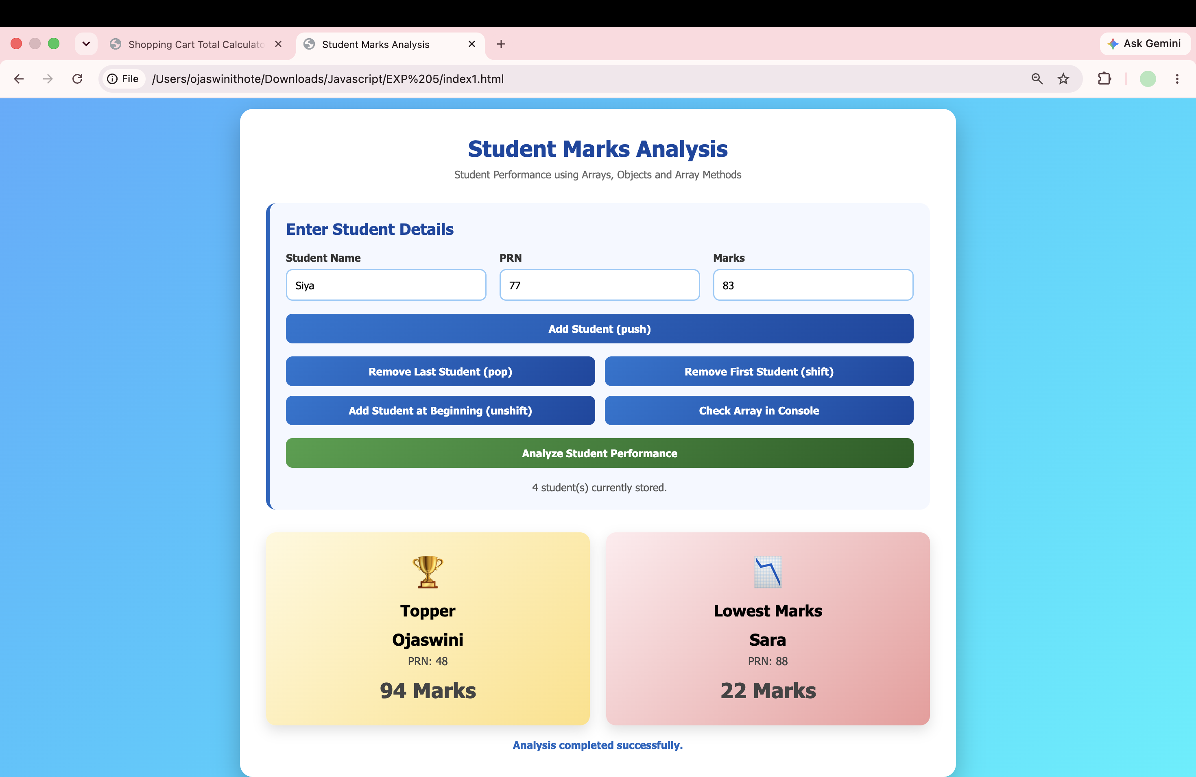

Result / Conclusion
Both tasks were completed successfully.
- Task 5.1 demonstrated forEach(), map(), filter(), and reduce() through a Shopping Cart Calculator that dynamically adds products, computes totals, applies discounts, and lists expensive products.
- Task 5.2 demonstrated map(), some(), Math.max(), and Math.min() by converting user-entered comma-separated numbers into an array of objects and finding the maximum and minimum values.
Thus, the experiment successfully demonstrated the practical use of JavaScript Array Methods and Object Handling in web applications.

